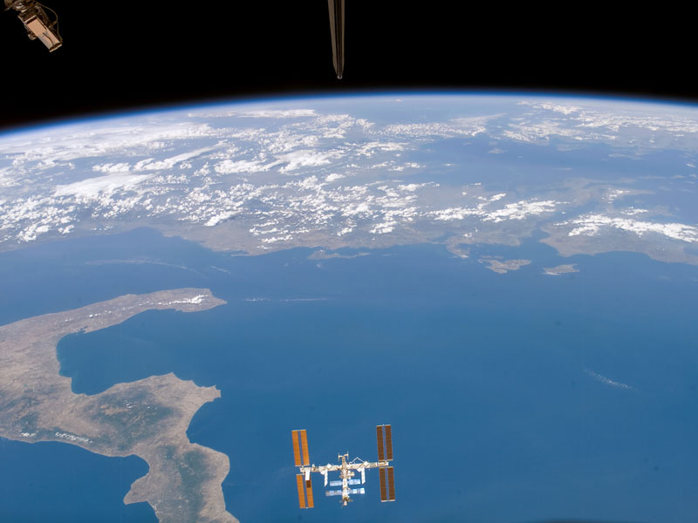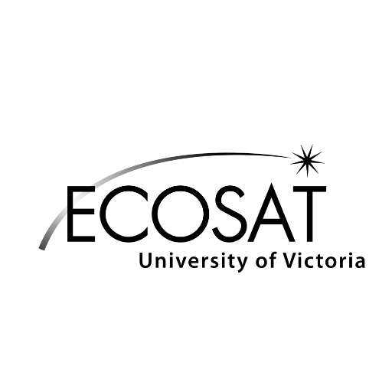Event: The CSSE presents *Space and Canada* featuring Dr. Don Kjosness  
Date: July 6th   
Time: 16:00  
Location: BWC A104 @ The University of Victoria  
  
This event is open to all. Representing the Canadian Society for Senior Engineers, Dr. Don Kjosness has over 25 years of experience in the space industry, with first hand experience working with Communications Technology Satellite (Hermes), Brazilsat, Telesat's Aniks C & D and Inmarsat.

Reserve your seat so that adequate snacks and coffee may be organized, complementary of the ESS. Reserve on Facebook or via email: mmccann@uvic.ca   
  
Agenda

16:00 Networking and snacks

16:15 Guest Speaker – Don Kjosness  
part 1: Canada and Space  
part 2: Platform and Applications  
part 3: ECOsat, Innovation, and Modern Industry

17:00 Questions  
  
17:15 Social wind-down